Analyzing Housing prices in metropolitan Areas of India

Project Report Template

# 1.INTRODUCTION

**1.1 Overview:**

Housing is a basic necessity for all human beings. However, it is also a major expense, especially in Metropolitan areas. In recent years, Housing prices in India have been rising rapidly, making it difficult for many People to afford to buy a home. This project aims to analyze housing prices in metropolitan areas of India and identify the factors that are driving them.

**1.2 purpose:**

Analyze the trends in housing prices in metropolitan areas of India over time

Identify the key factors that are driving housing prices in these areas

Develop a model to predict housing prices in metropolitan areas of India

# 2.PROBLEM DEFINITION & DESIGN THINKING

### 

**2.1 Empathy Map**

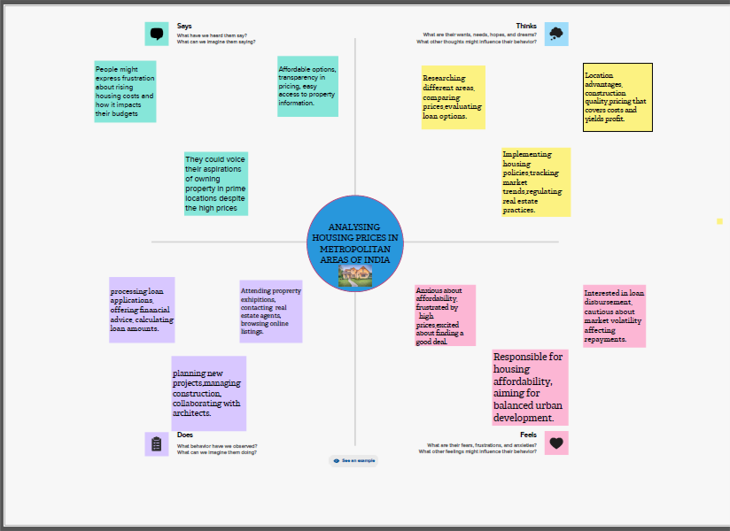 **2.2 Ideation & Brainstorming Map** 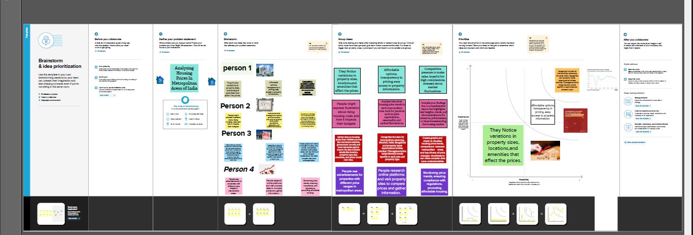

3. RESULT 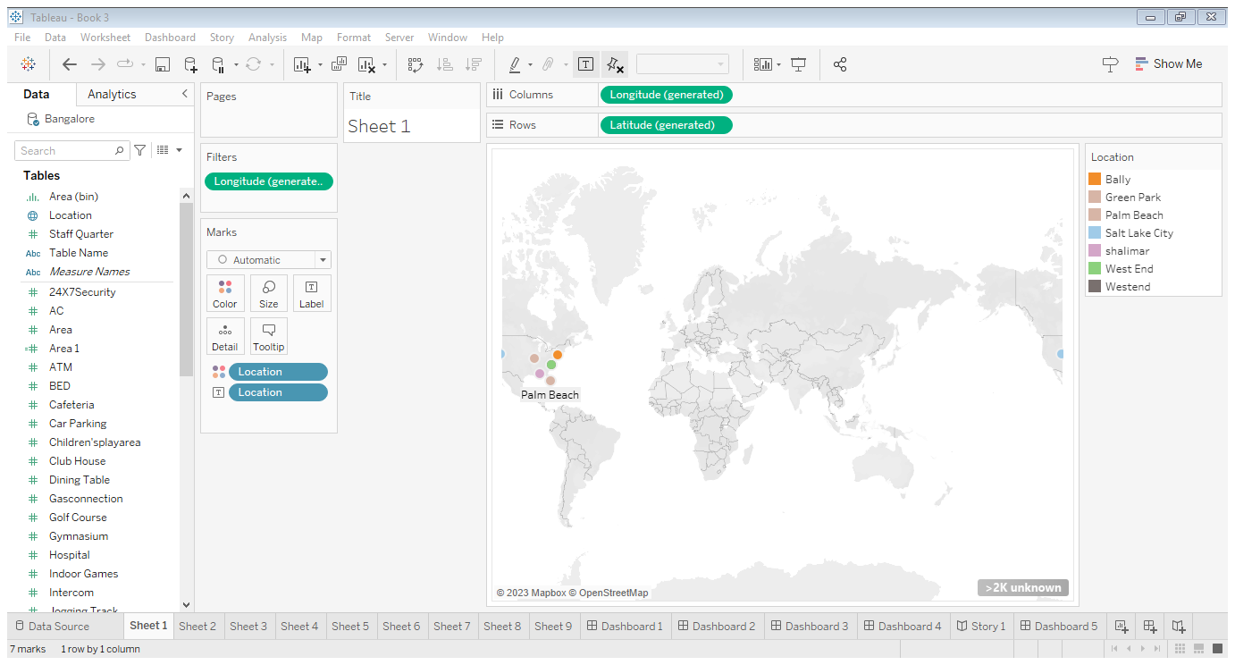

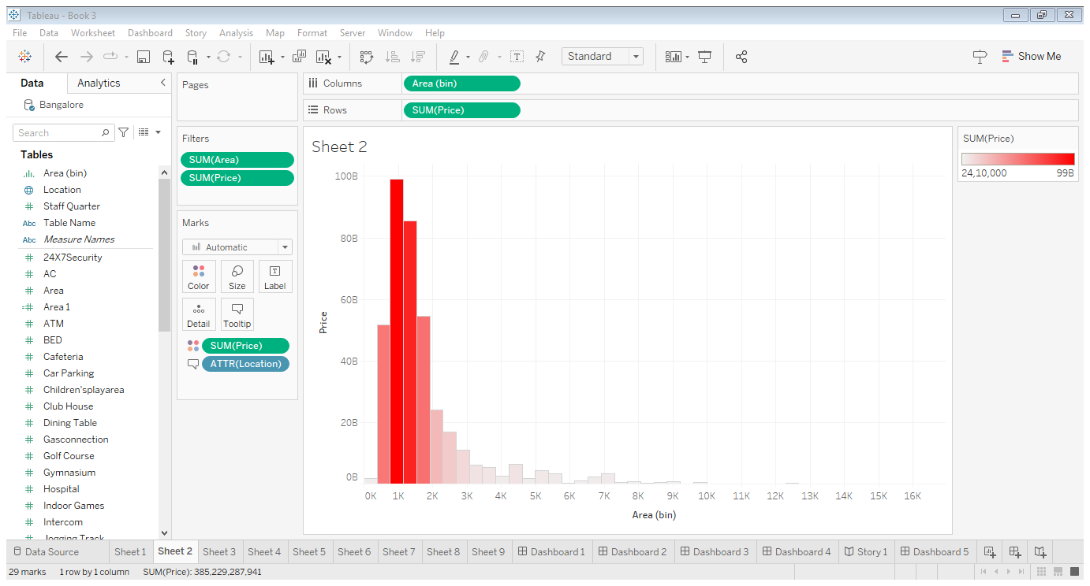

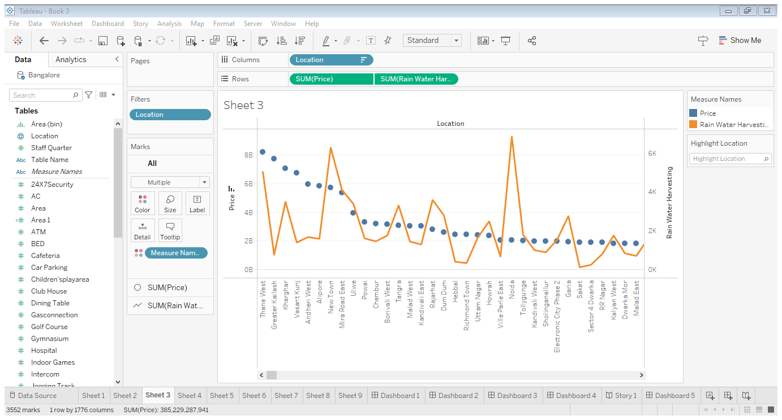

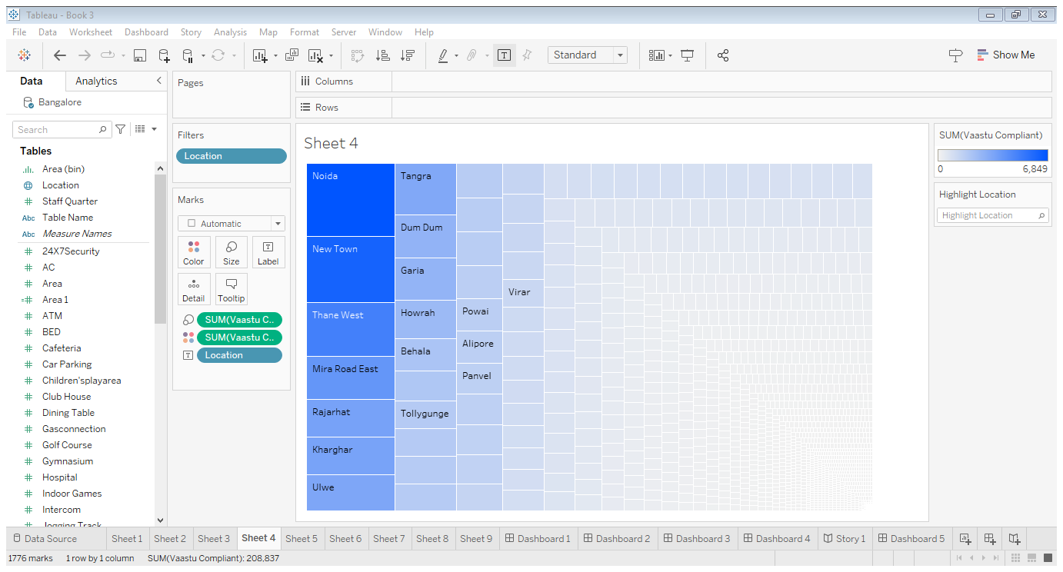

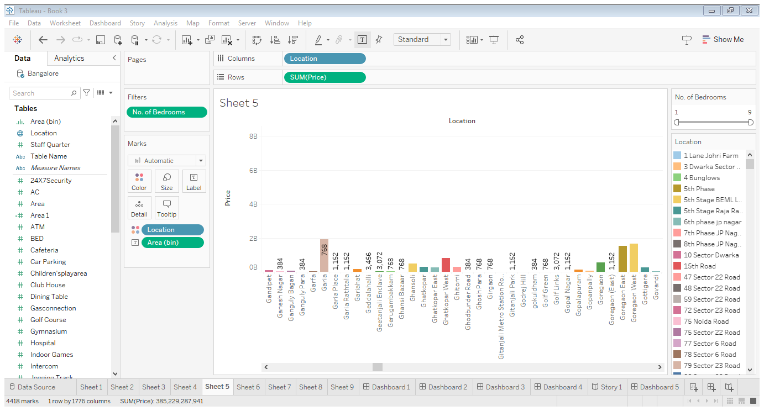

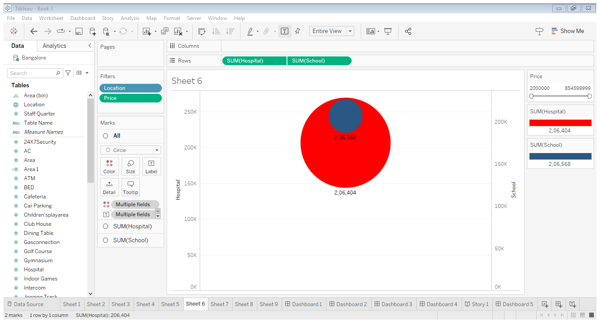

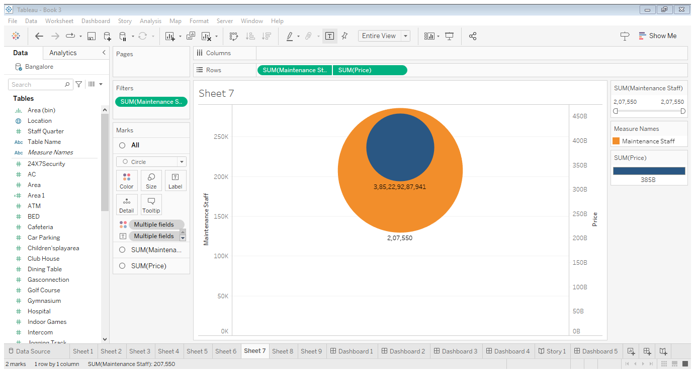

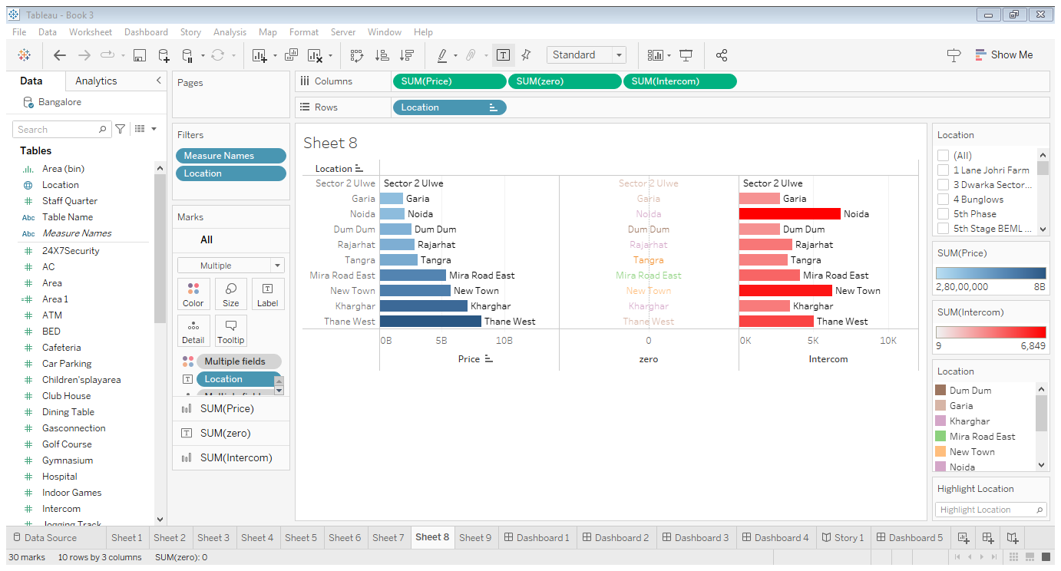

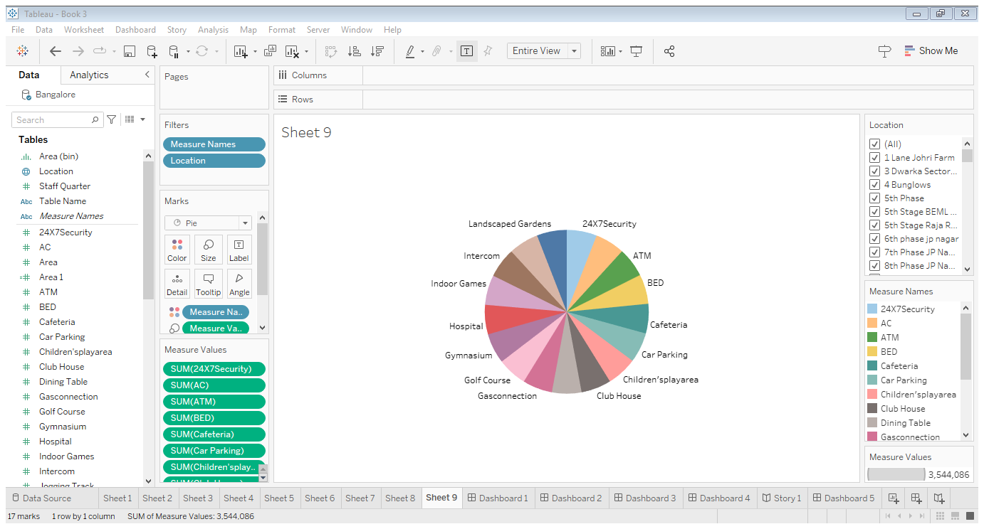

4. ADVANTAGES & DISADVANTAGES

**Advantages :**

**Market Insights: It** provides a comprehensive view of the real estate market, helping buyers, sellers, and investors make informed decisions .

**Investment Opportunities:** Investors can identify potential areas for profitable real estate investments based on price trends and growth potential .

**Policy Implications**: It can inform policymakers about housing affordability and the need for regulations or incentives to address housing issues.

**Urban planning:** Understanding housing prices aids in urban planning, helping authorities allocate resources and infrastructure development.

**Disadvantages:**

**Data Quality :** Obtaining accurate and up-to-date data on housing prices can be challenging, especially in developing countries like India , where data collection and reporting systems may be inconsistent or incomplete.

**Regional variability**: Housing markets can vary significantly from one metropolitan area to another, making it difficult to generalize findings or create a one-size-fits-all analysis.

**Lack of Transparency**: The real estate sector in India has historically been characterized by limited transparency, which can hinder a comprehensive analysis .Many transactions go unrecorded or underreported.

**Speculation and Black Money** :Speculation and the use of black money ( unaccounted funds ) in real estate transactions can distort price data and make it difficult to assess the true market value.

5. APPLICATIONS

**Real Estate Investment**: Investors use this analysis to identify areas with potential for high returns, helping them make informed investment decisions.

**Property Valuation:** Homebuyers and sellers can assess the fair market value of a property, aiding in negotiations and decision-making.

6.CONCLUSION

This project will provide valuable insights into the housing market in India and help to identify the factors that are driving housing prices in metropolitan areas. The projects findings can be used by policymakers, developers, and consumers to make informed decisions about the housing market.

7.FUTURE SCOPE

**Real Estate Market Dynamics:** Understanding housing price trends can help investors, developers, and policymakers make informed decisions in a rapidly changing market.

**Urbanization:** As urban populations continue to grow, demand for housing in metropolitan areas will remain strong , making housing price analysis crucial for city planning.

**Data Analytics:** Advancements in data analytics and machine learning can provide more accurate predictions of future housing prices, aiding both buyers and sellers.

**Policy Formulation :** Data analysis can assist in formulating housing policies, addressing affordability issues, and ensuring sustainable urban development.